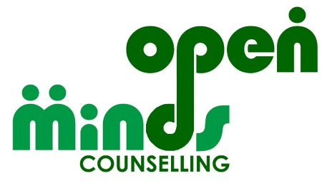
Counselling one to one and in groups for children aged 8 and over, and adults

We are a people friendly counselling service,
open to people of all genders, ethnicities, faiths, cultures, sexualities, neurotypes & disabilities

Adult, Children, Young People’s Counsellor (4 posts available)

Permanent, subject to funding availability, ends 31st March 2023 if funding not continued.

Working hours: Flexible, but predominantly out of School hours, including evenings and Saturdays.

Roles are as follows:
Job Title | Adult, Children, Young People’s Counsellor | Adult, Children, Young People’s Counsellor
Hourly rate | £14 | £14
Weekly hours | 3.5 | 3.5
Expected session times | 4pm 5pm 6pm  Weekdays | 10am 11.15am 12.30pm  Saturdays
Provision | Video call / telephone | In person
Client group | Individuals who have experienced life distress | Individuals who have experienced life distress
Client ages | CYP = 13 – 17  Adults, all ages | CYP = 8 – 14  Occasional older children/ adults
Location | Home working | 28 Christchurch Road, DN12QL
Number of vacancies | 3 | 1

Open Minds Counselling Service is a successful mental health charity providing a range of services to help support people’s mental health recovery and wellbeing including counselling, peer support, training, volunteer development and information and guidance.

We are looking for compassionate and resilient individuals. You will be a qualified counsellor with 1 or more years’ experience of working with children and young people therapeutically and a good understanding of the needs of children and young people who have experienced psychological distress.

The administrative elements of your role will include submitting electronic notes in a timely fashion and following appropriate policies.

The support elements of your role will include a small case load of your own CYP clients. You may be asked to complete initial assessments of CYP.

For an application pack visit https://www.counsellingdoncaster.com/vacancies or if you need support to download an application please email hr@counsellingdoncaster.com
If you would like an informal discussion about this post, please contact Helen Mason, Managing Director on hr@counsellingdoncaster.com.

Your completed application form should be returned to: hr@counsellingdoncaster.com

Closing date: 5pm 12th March 2022
Interview date: Saturday 19th March 2022

